Implementation of Post Processing Effects using Shaders

Finian J. Graham

Contents

General Use of Post Processing Effects 2

Implementation 3

Gradient Tint 3

HSL Colour Shift 3

Basic Blur 4

Underwater 5

Two-Pass Gaussian Blur 6

Retro 7

Bloom 8

Multi-effect implementation 9

Polygon Area Effect 9

# General Use of Post Processing Effects

Post processing is utilized in both gameplay and artistic applications for a variety of different reasons. These reasons range from immersion, by making a scene look more realistic, to creativity, where a scene can be adjusted to take on a particular style.

An example of post processing to enhance immersion and realism is Bloom. Since a computer monitor can only reach a certain brightness, it can be tricky to truly emphasis how bright an object is. To do this, we utilize blooming to add a kind of “glow” to extremely bright objects.

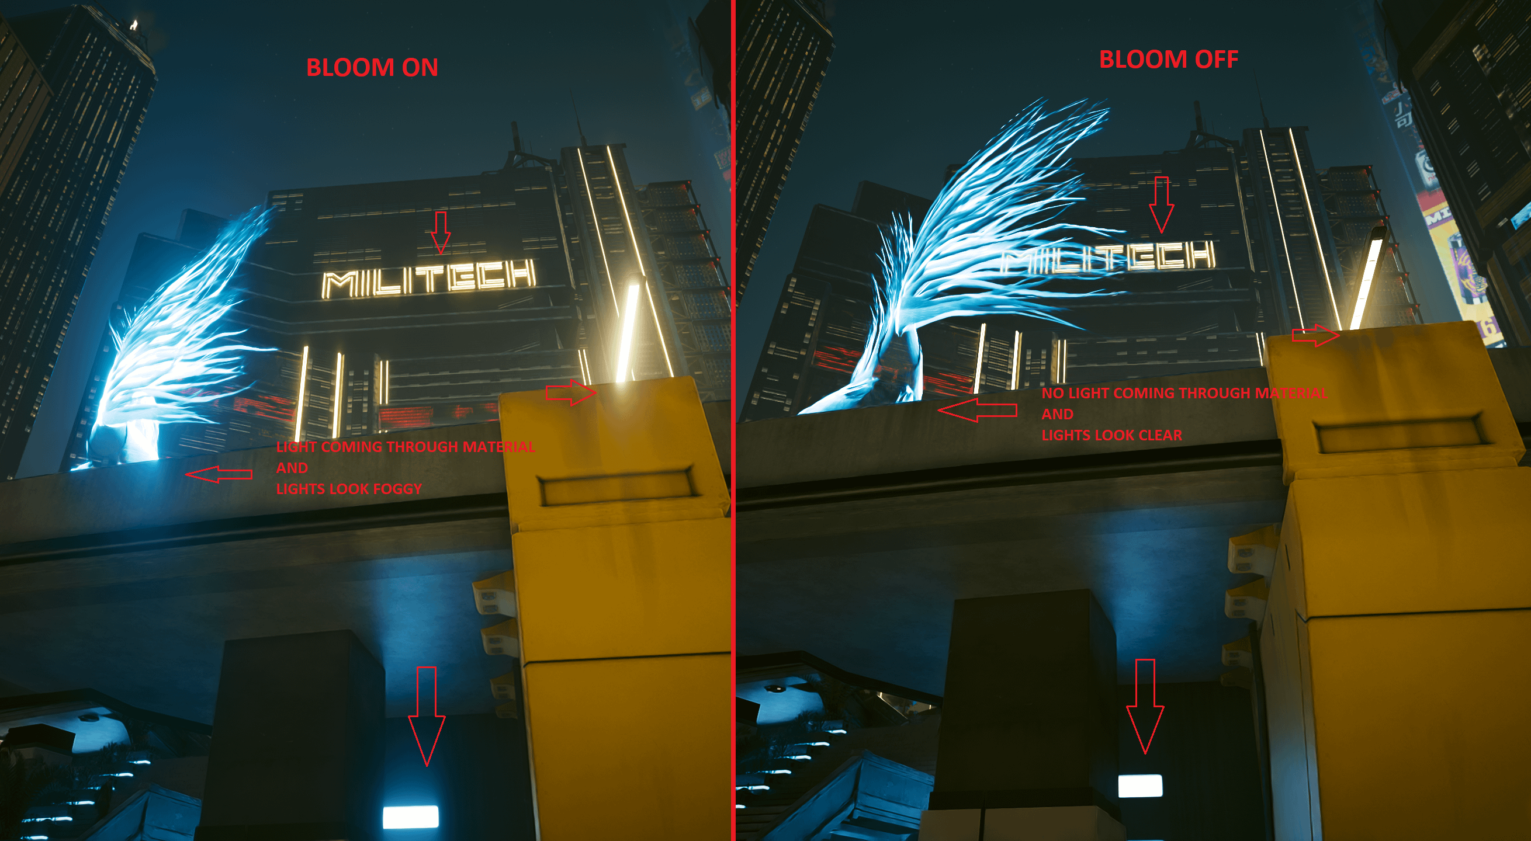

Figure 1: Bloom Example

(r/cyberpunkgame, 2023)

On the other hand, we can use “Cel Shading” as a form of artistic post processing to give a unique style to our game. Cel Shading converts lighting into a more banded transition, removing smooth blurry transitions in favour of a sharp contrasting line between darker and lighter sections of a model. 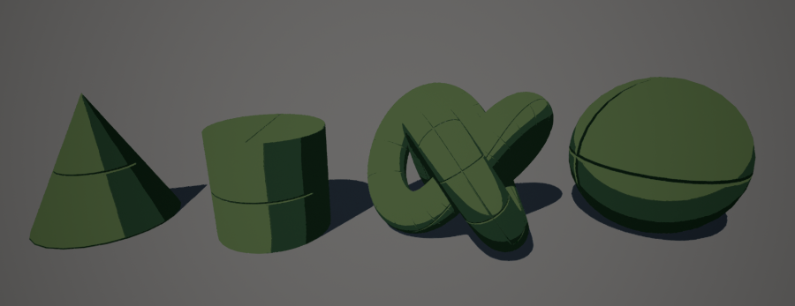

Figure 2: Cel Shading Example

(Langmead, n.d.)

# Implementation

## Full Screen Effects

To create full screen post processing effects, the entire scene is rendered to a texture that can be modified. Once this texture is created, it is then drawn to a Quad that covers the entire viewport with the shader applied.

## Gradient Tint

Tinting the scene is simply done by multiplying the scene colour with a target colour. In order to achieve a gradient, two colours are supplied by the CPU and then transitioned between using a lerp based on how far down the screen the pixel is.

To improve the look of this gradient, a hue shift could be used instead.

Figure 3: Gradient Tint

### HSL Colour Shift

To make the two colours chosen for this gradient shift between different hues, a HSL to RGB conversion is used. The CPU can then increase the Hue of each colour over time before passing the new RGB values to the GPU.

Figure 4: HSL to RGB Function.

## Basic Blur

For the basic blur implementation, I utilized an Average Blur approach in which each pixel is set to the average value of the surrounding pixels, weighted to a mask. A benefit to this approach is that you can easily alter the effect by changing the mask, but it comes with the downside of being very slow if the mask is too large.

Figure 5: Basic Average Blur

Figure 6: Blur Mask

## Underwater

Figure 7: Underwater.

Figure 8: Underwater Normal Map.

## Two-Pass Gaussian Blur

Figure 9: Gaussian Blur First Pass.

Figure 10: Gaussian Blur Second Pass.

## Retro

Figure 11: Low Resolution Pass.

Figure 12: Colour Filter Pass.

## Bloom

Figure 13: Brightness Filter Pass.

Figure 14: Basic Blur On Brightness Mask.

Figure 15: Bloom.

## Multi-effect implementation

Figure 16: Retro + Basic Blur

## Polygon Area Effect

Figure 17: Localized Blur Through Window

# References

Langmead, A. (n.d.). *Cel Shading Post Process*. Retrieved from Github: https://nerivec.github.io/old-ue4-wiki/pages/cel-shading-post-process.html

*r/cyberpunkgame*. (2023, October). Retrieved from Reddit: https://www.reddit.com/r/cyberpunkgame/comments/16qyl0q/light_bloom_comparison_on_vs_off/